augmentedRCBD

Details 2

ANOVA, Treatment Adjusted 2

ANOVA, Block Adjusted 2

Standard Errors 3

Critical Difference (5%) 3

Coefficient of Variance 3

Overall Adjusted Mean 4

Check Statistics 4

PH 4

NB 5

NP 5

LOP 5

100 SW 5

TSW 5

DS 5

Descriptive Statistics 6

Frequency Distribution 6

PH 6

NB 7

NP 7

LOP 8

100 SW 8

TSW 9

DS 9

Genetic Variability Analysis 10

Genetic Variablity Analysis Plots 10

Phenotypic and Genotypic Coefficient of Variability 10

Broad Sense Heritability 11

Genetic Advance Over Mean 11

Adjusted Means 12

Warnings 17

Model 17

Frequency Distribution 17

Genetic Variablity Analysis 18

# Details

| Item | Details |
| --- | --- |
| Number of blocks | 4 |
| Number of treatments | 102 |
| Number of check treatments | 2 |
| Number of test treatments | 100 |
| Check treatments | IC-202781, V-585 |
| Number of Traits | 7 |
| Traits | PH, NB, NP, LOP, 100 SW, TSW, DS |

# ANOVA, Treatment Adjusted

| **Source** | **Df** | **X100.SW** | **DS** | **LOP** | **NB** | **NP** | **PH** | **TSW** |
| --- | --- | --- | --- | --- | --- | --- | --- | --- |
| Block (ignoring Treatments) | 3 | 5.37 ns | 437.23 ** | 3.69 ** | 0.23 ns | 86.57 ** | 1528.55 ** | 9131.1 ** |
| Treatment (eliminating Blocks) | 101 | 9.39 * | 64.64 * | 2.61 ** | 0.16 ns | 8.49 ** | 108.44 ns | 1455.24 ** |
| Treatment: Check | 1 | 1.62 ns | 21.07 ns | 2.65 ns | 0.01 ns | 11.52 * | 163.62 ns | 38.72 ns |
| Treatment: Test and Test vs. Check | 100 | 9.46 * | 65.08 * | 2.61 ** | 0.16 ns | 8.46 ** | 107.89 ns | 1469.41 ** |
| Residuals | 23 | 4.04 | 30.29 | 0.66 | 0.1 | 2.66 | 64.92 | 557.24 |

ns P > 0.05; * P <= 0.05; ** P <= 0.01

# ANOVA, Block Adjusted

| **Source** | **Df** | **X100.SW** | **DS** | **LOP** | **NB** | **NP** | **PH** | **TSW** |
| --- | --- | --- | --- | --- | --- | --- | --- | --- |
| Treatment (ignoring Blocks) | 101 | 9.2 * | 76.97 ** | 2.68 ** | 0.16 ns | 10.38 ** | 146.68 * | 1719.95 ** |
| Treatment: Check | 1 | 1.62 ns | 21.07 ns | 2.65 ns | 0.01 ns | 11.52 * | 163.62 ns | 38.72 ns |
| Treatment: Test vs. Check | 1 | 0.17 ns | 30.37 ns | 0.06 ns | 0.01 ns | 1.32 ns | 7.8 ns | 4.47 ns |
| Treatment: Test | 99 | 9.37 * | 78.01 ** | 2.71 ** | 0.16 ns | 10.47 ** | 147.92 * | 1754.26 ** |
| Block (eliminating Treatments) | 3 | 11.61 ns | 22.16 ns | 1.31 ns | 0.28 ns | 22.62 ** | 241.02 * | 219.37 ns |
| Residuals | 23 | 4.04 | 30.29 | 0.66 | 0.1 | 2.66 | 64.92 | 557.24 |

ns P > 0.05; * P <= 0.05; ** P <= 0.01

# Standard Errors

| **Comparison** | **X100.SW** | **DS** | **LOP** | **NB** | **NP** | **PH** | **TSW** |
| --- | --- | --- | --- | --- | --- | --- | --- |
| A Test Treatment and a Control Treatment | 2.75 | 7.54 | 1.12 | 0.44 | 2.23 | 11.03 | 32.32 |
| Control Treatment Means | 1.42 | 3.89 | 0.58 | 0.23 | 1.15 | 5.7 | 16.69 |
| Two Test Treatments (Different Blocks) | 3.48 | 9.53 | 1.41 | 0.56 | 2.82 | 13.96 | 40.89 |
| Two Test Treatments (Same Block) | 2.84 | 7.78 | 1.15 | 0.46 | 2.31 | 11.39 | 33.38 |

# Critical Difference (5%)

| **Comparison** | **X100.SW** | **DS** | **LOP** | **NB** | **NP** | **PH** | **TSW** |
| --- | --- | --- | --- | --- | --- | --- | --- |
| A Test Treatment and a Control Treatment | 5.7 | 15.59 | 2.31 | 0.91 | 4.62 | 22.82 | 66.87 |
| Control Treatment Means | 2.94 | 8.05 | 1.19 | 0.47 | 2.39 | 11.79 | 34.53 |
| Two Test Treatments (Different Blocks) | 7.2 | 19.72 | 2.92 | 1.15 | 5.84 | 28.87 | 84.58 |
| Two Test Treatments (Same Block) | 5.88 | 16.1 | 2.38 | 0.94 | 4.77 | 23.57 | 69.06 |

# Coefficient of Variance

| **Trait** | **CV** |
| --- | --- |
| PH | 21.39 |
| NB | 13.18 |
| NP | 26.71 |
| LOP | 6.37 |
| 100 SW | 19.8 |
| TSW | 26.86 |
| DS | 81.23 |

# Overall Adjusted Mean

| **Trait** | **Overall.adjusted.mean** |
| --- | --- |
| PH | 37.96 |
| NB | 2.46 |
| NP | 6.18 |
| LOP | 12.84 |
| 100 SW | 10.2 |
| TSW | 89.54 |
| DS | 7.27 |

# Check Statistics

## PH

| **Treatment** | **r** | **Means** | **SE** | **Min** | **Max** |
| --- | --- | --- | --- | --- | --- |
| IC-202781 | 4 | 34.665 | 6.923503 | 21.76 | 54.30 |
| V-585 | 4 | 43.710 | 7.757338 | 24.98 | 62.96 |

## NB

| **Treatment** | **r** | **Means** | **SE** | **Min** | **Max** |
| --- | --- | --- | --- | --- | --- |
| IC-202781 | 4 | 2.40 | 0.2160247 | 2 | 3.0 |
| V-585 | 4 | 2.45 | 0.2629956 | 2 | 3.2 |

## NP

| **Treatment** | **r** | **Means** | **SE** | **Min** | **Max** |
| --- | --- | --- | --- | --- | --- |
| IC-202781 | 4 | 5.45 | 0.8460693 | 3.4 | 7.2 |
| V-585 | 4 | 7.85 | 1.1757976 | 5.2 | 10.6 |

## LOP

| **Treatment** | **r** | **Means** | **SE** | **Min** | **Max** |
| --- | --- | --- | --- | --- | --- |
| IC-202781 | 4 | 12.18 | 0.4446722 | 11.48 | 13.48 |
| V-585 | 4 | 13.33 | 0.4778773 | 12.76 | 14.76 |

## 100 SW

| **Treatment** | **r** | **Means** | **SE** | **Min** | **Max** |
| --- | --- | --- | --- | --- | --- |
| IC-202781 | 4 | 9.875 | 1.104819 | 7.1 | 12.5 |
| V-585 | 4 | 10.775 | 2.170397 | 7.8 | 17.0 |

## TSW

| **Treatment** | **r** | **Means** | **SE** | **Min** | **Max** |
| --- | --- | --- | --- | --- | --- |
| IC-202781 | 4 | 92.7 | 10.288748 | 69.5 | 112.1 |
| V-585 | 4 | 88.3 | 7.683098 | 67.4 | 103.6 |

## DS

| **Treatment** | **r** | **Means** | **SE** | **Min** | **Max** |
| --- | --- | --- | --- | --- | --- |
| IC-202781 | 4 | 3.697318 | 1.429612 | 0 | 6.896552 |
| V-585 | 4 | 6.943333 | 2.598373 | 0 | 12.500000 |

# Descriptive Statistics

| **Trait** | **Count** | **Mean** | **Std.Error** | **Std.Deviation** | **Min** | **Max** | **Skewness** | **Kurtosis** |
| --- | --- | --- | --- | --- | --- | --- | --- | --- |
| PH | 118 | 37.65 | 0.9 | 9.78 | 12.96 | 63.02 | 0.57 * | 3.22 ns |
| NB | 118 | 2.45 | 0.04 | 0.39 | 1.7 | 3.79 | 1.05 ** | 5.14 ** |
| NP | 118 | 6.11 | 0.25 | 2.71 | 1.85 | 20.85 | 2.29 ** | 11.53 ** |
| LOP | 118 | 12.81 | 0.14 | 1.51 | 8.97 | 19.21 | 1.18 ** | 6.61 ** |
| 100 SW | 118 | 10.2 | 0.29 | 3.2 | 2.31 | 24.87 | 1.9 ** | 10.86 ** |
| TSW | 118 | 88.14 | 3.37 | 36.66 | 34.3 | 233.7 | 1.68 ** | 6.39 ** |
| DS | 118 | 7.07 | 0.7 | 7.65 | 0 | 30.94 | 1.2 ** | 3.68 ns |

ns P > 0.05; * P <= 0.05; ** P <= 0.01

# Frequency Distribution

## PH

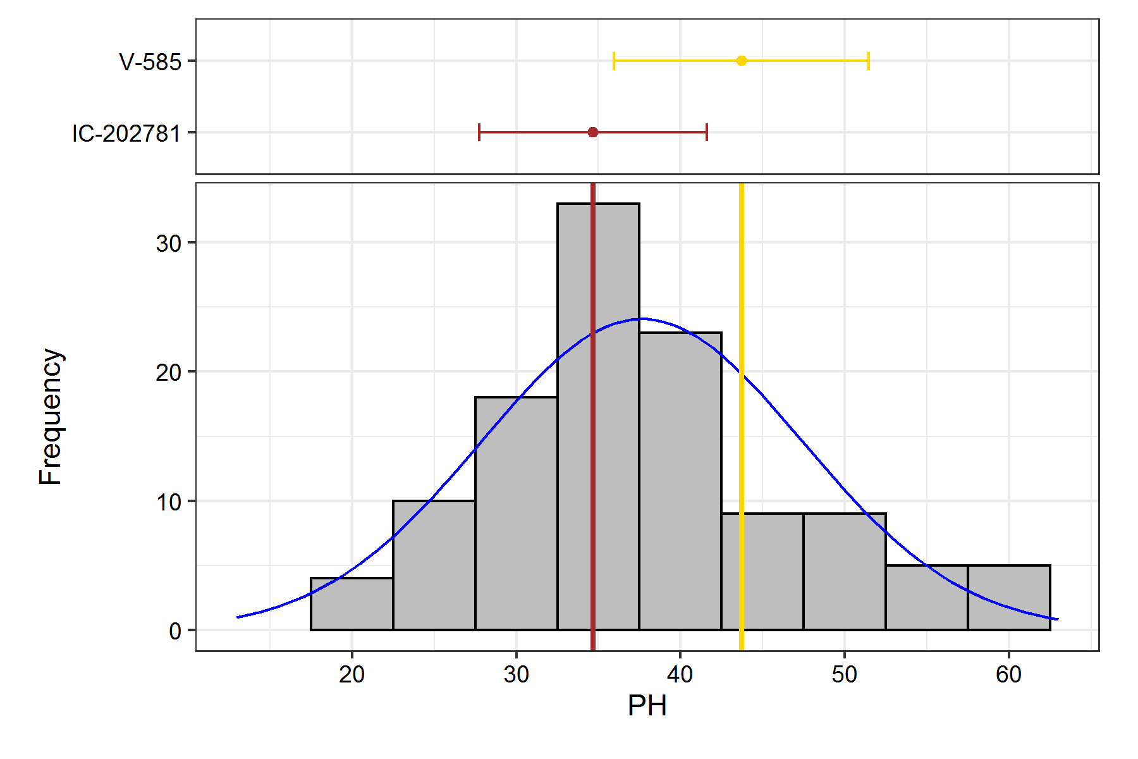

## NB

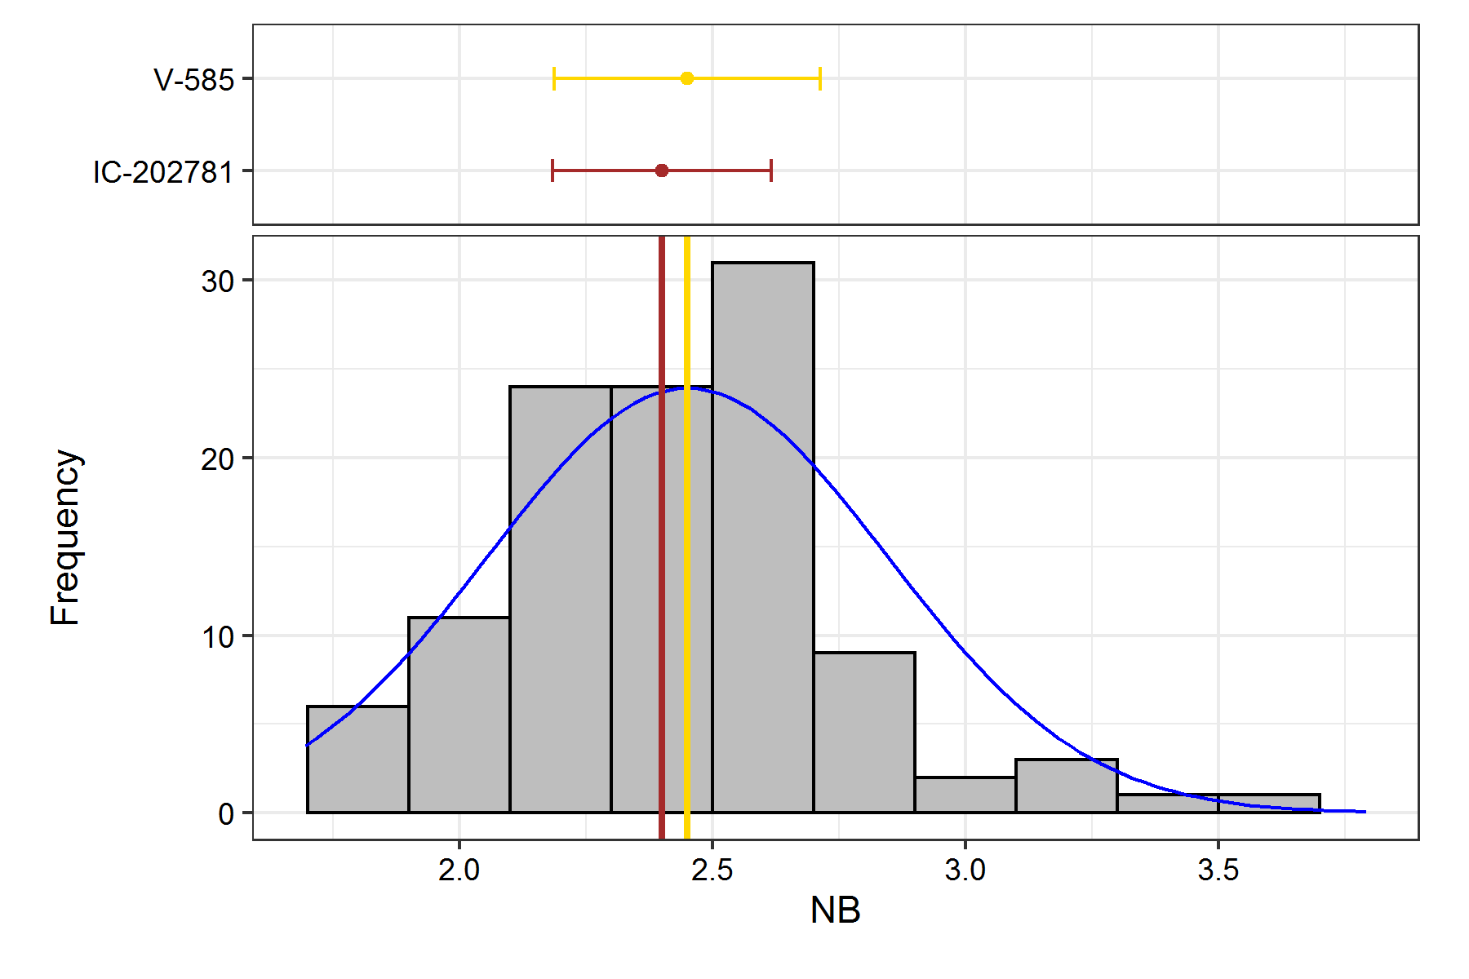

## NP

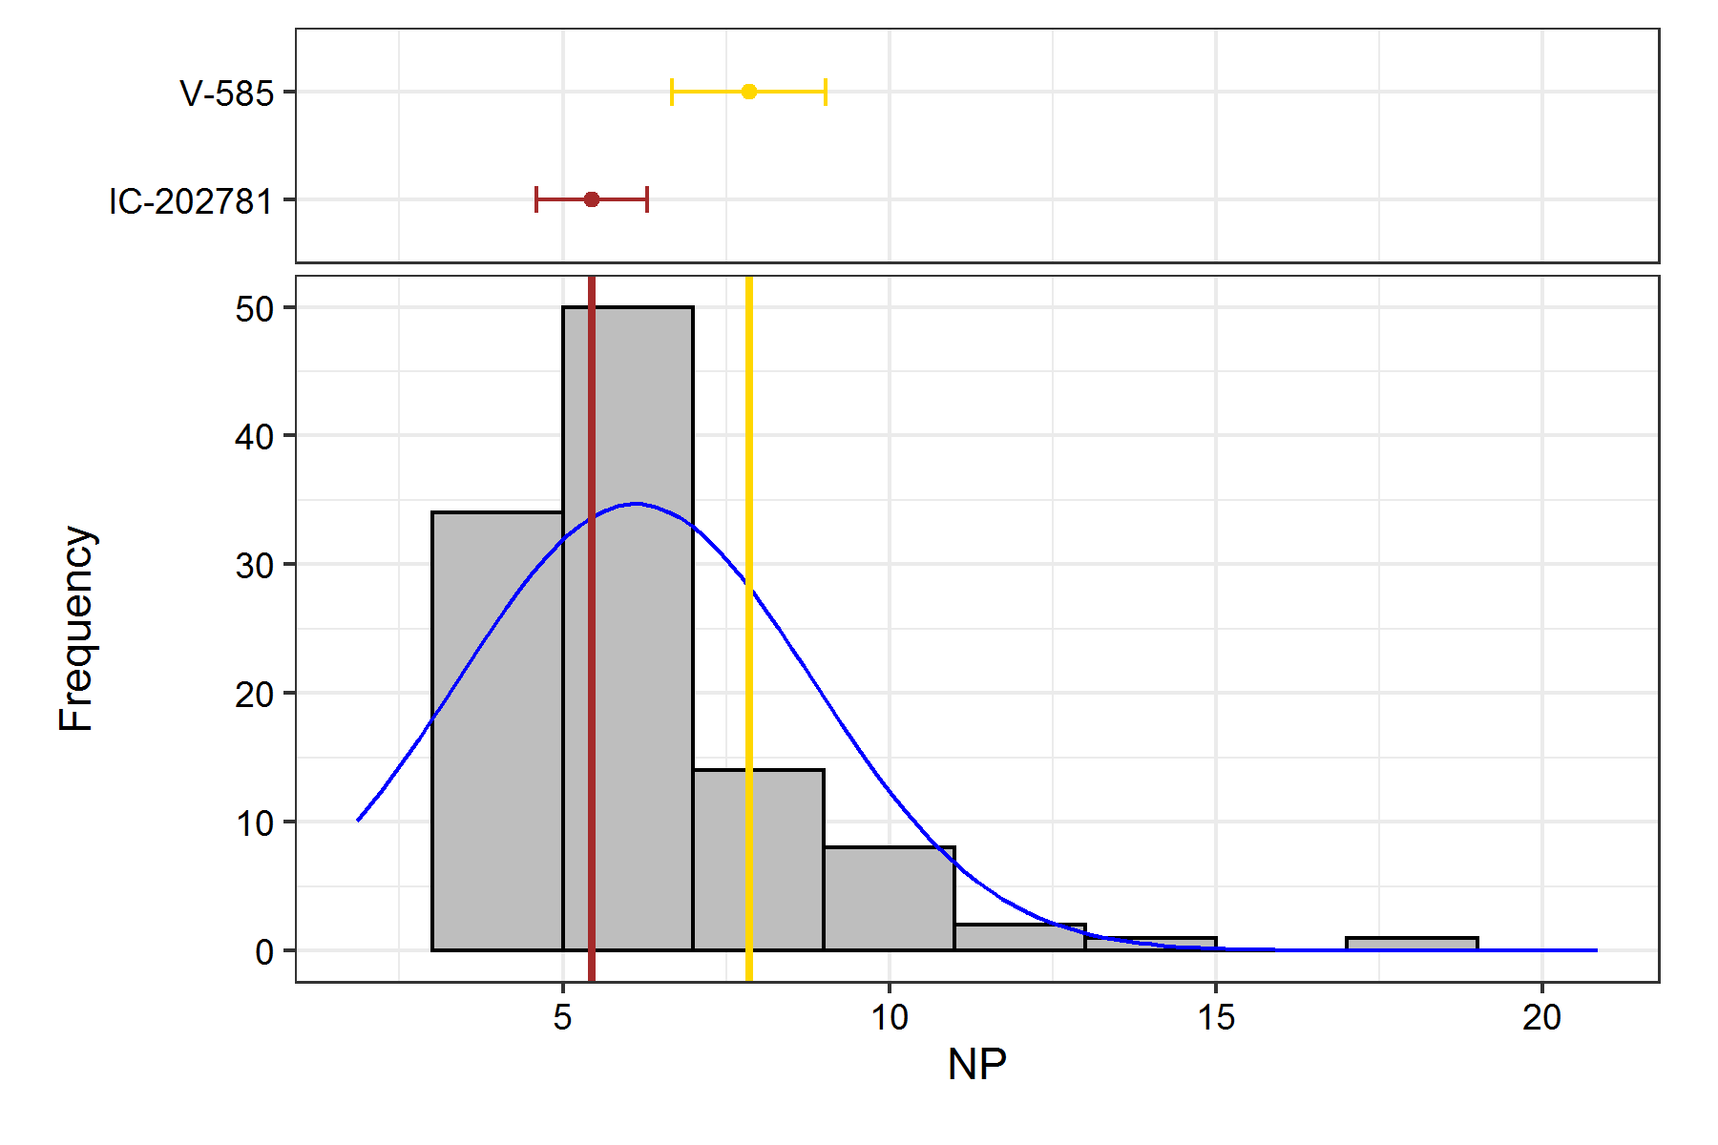

## LOP

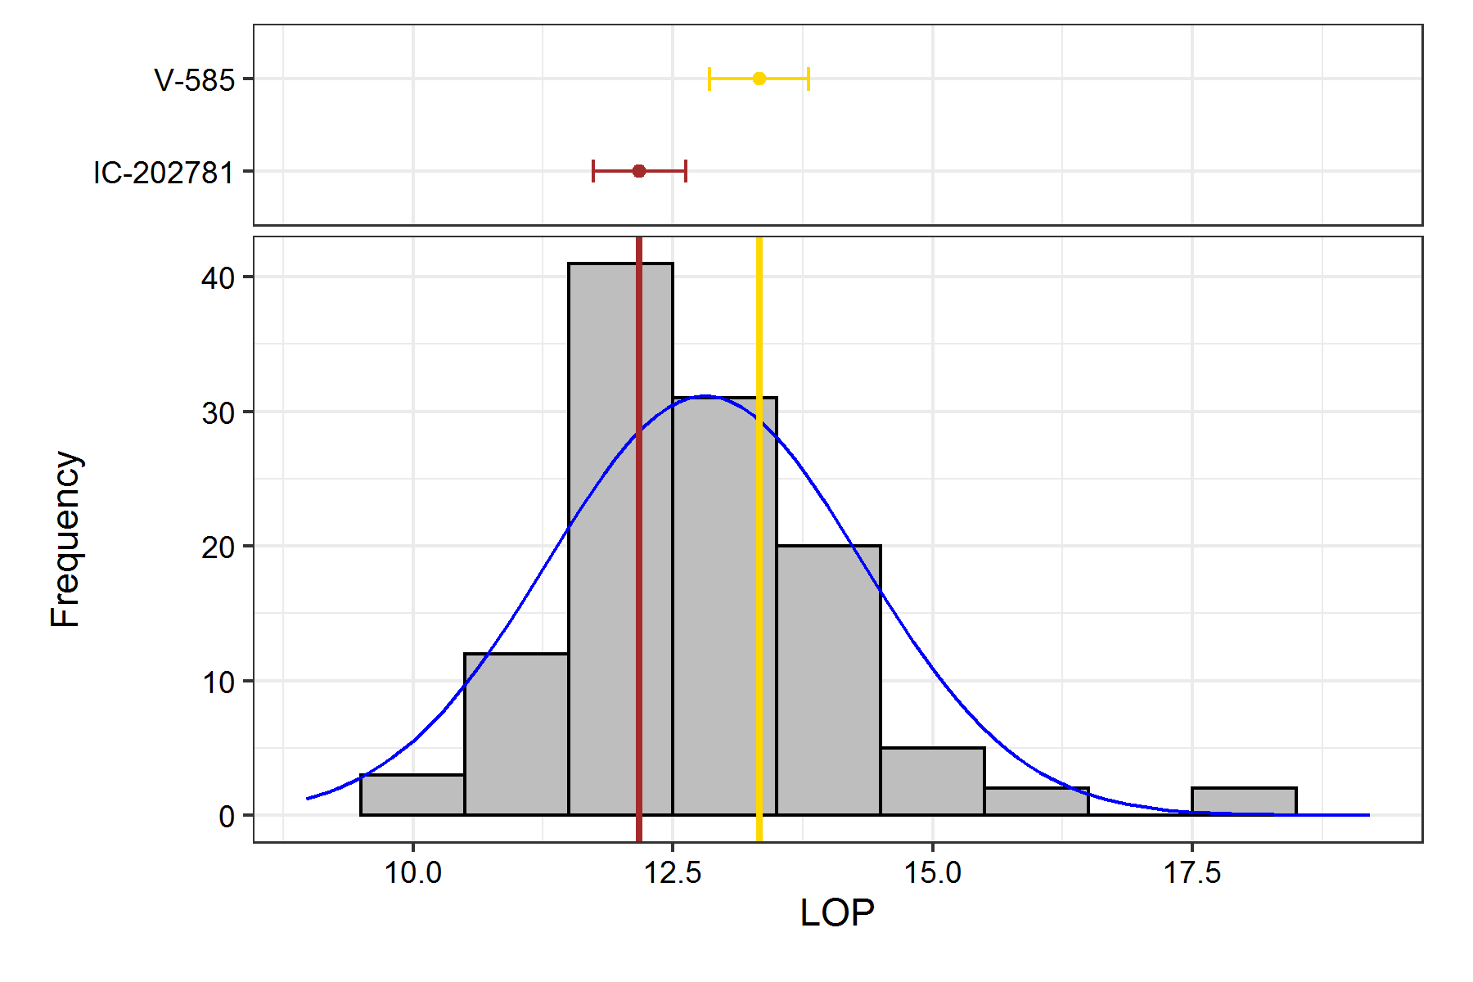

## 100 SW

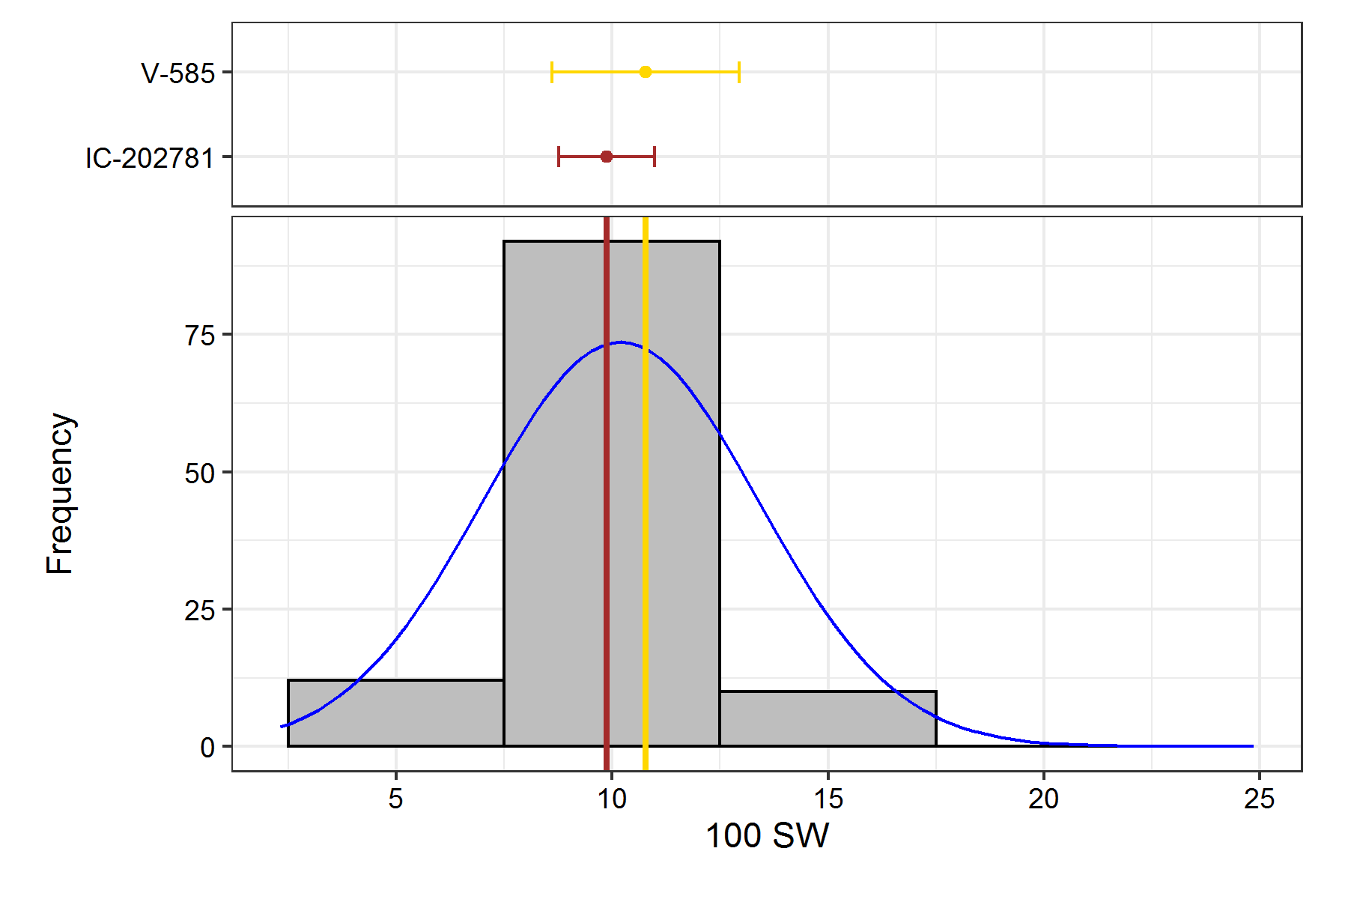

## TSW

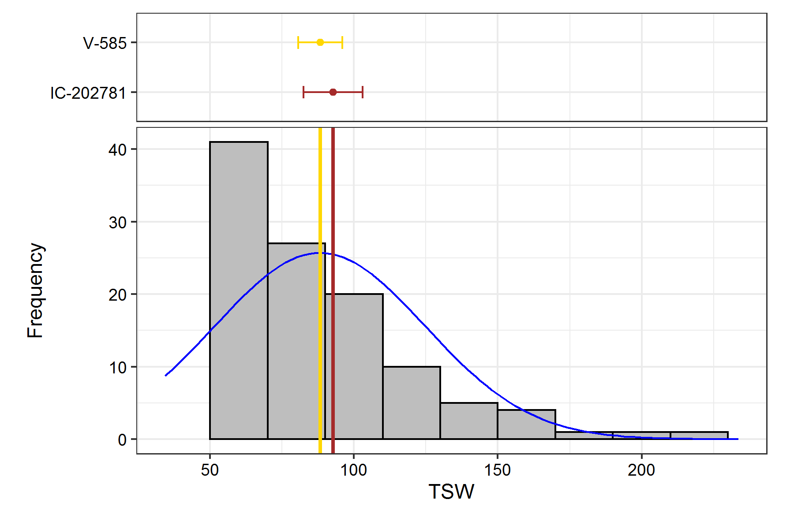

## DS

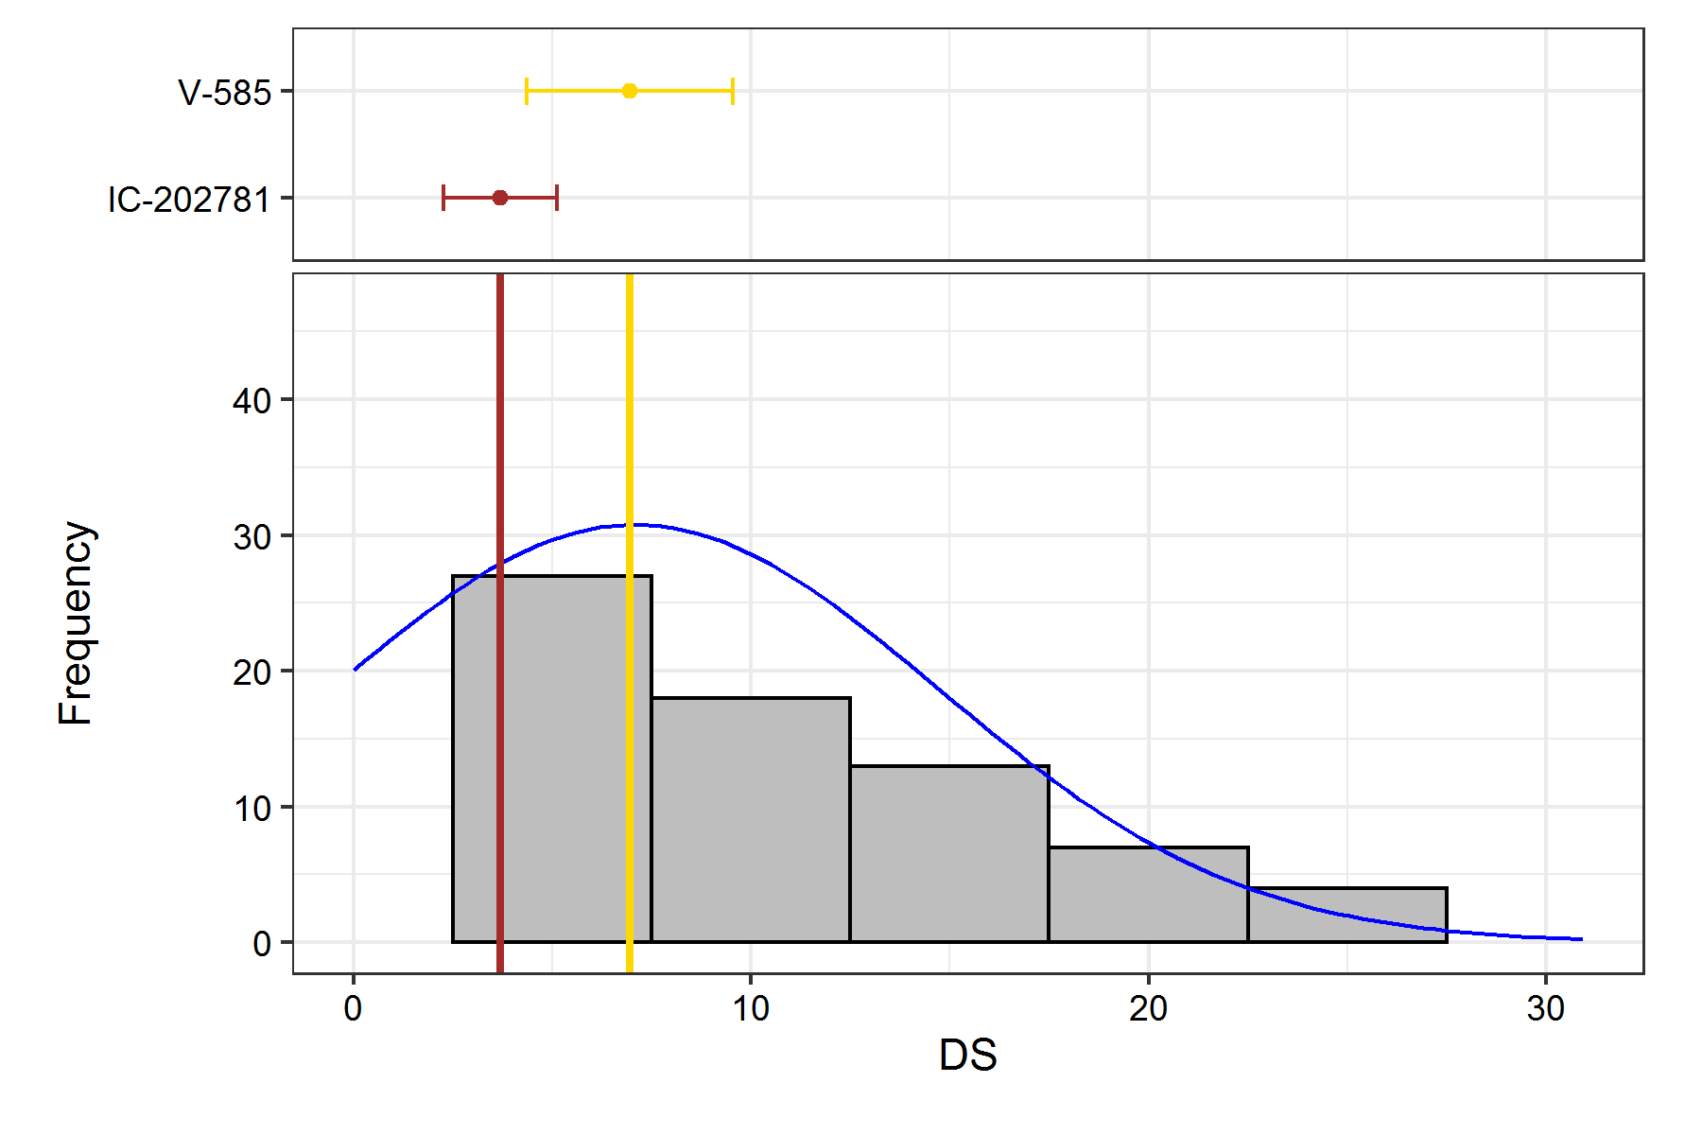

# Genetic Variability Analysis

| **Trait** | **Mean** | **PV** | **GV** | **EV** | **GCV** | **GCV.category** | **PCV** | **PCV.category** | **ECV** | **hBS** | **hBS.category** | **GA** | **GAM** | **GAM.category** |
| --- | --- | --- | --- | --- | --- | --- | --- | --- | --- | --- | --- | --- | --- | --- |
| PH | 37.65 | 147.92 | 83 | 64.92 | 24.2 | High | 32.3 | High | 21.4 | 56.11 | Medium | 14.08 | 37.39 | High |
| NB | 2.45 | 0.16 | 0.06 | 0.1 | 9.64 | Low | 16.31 | Medium | 13.15 | 34.97 | Medium | 0.29 | 11.77 | Medium |
| NP | 6.11 | 10.47 | 7.81 | 2.66 | 45.75 | High | 52.97 | High | 26.71 | 74.58 | High | 4.98 | 81.51 | High |
| LOP | 12.81 | 2.71 | 2.04 | 0.66 | 11.16 | Medium | 12.85 | Medium | 6.36 | 75.48 | High | 2.56 | 20 | High |
| 100 SW | 10.2 | 9.37 | 5.33 | 4.04 | 22.64 | High | 30.02 | High | 19.72 | 56.85 | Medium | 3.59 | 35.21 | High |
| TSW | 88.14 | 1754.26 | 1197.01 | 557.24 | 39.25 | High | 47.52 | High | 26.78 | 68.23 | High | 58.96 | 66.89 | High |
| DS | 7.07 | 78.01 | 47.72 | 30.29 | 97.68 | High | 124.89 | High | 77.82 | 61.17 | High | 11.15 | 157.6 | High |

# Genetic Variablity Analysis Plots

## Phenotypic and Genotypic Coefficient of Variability

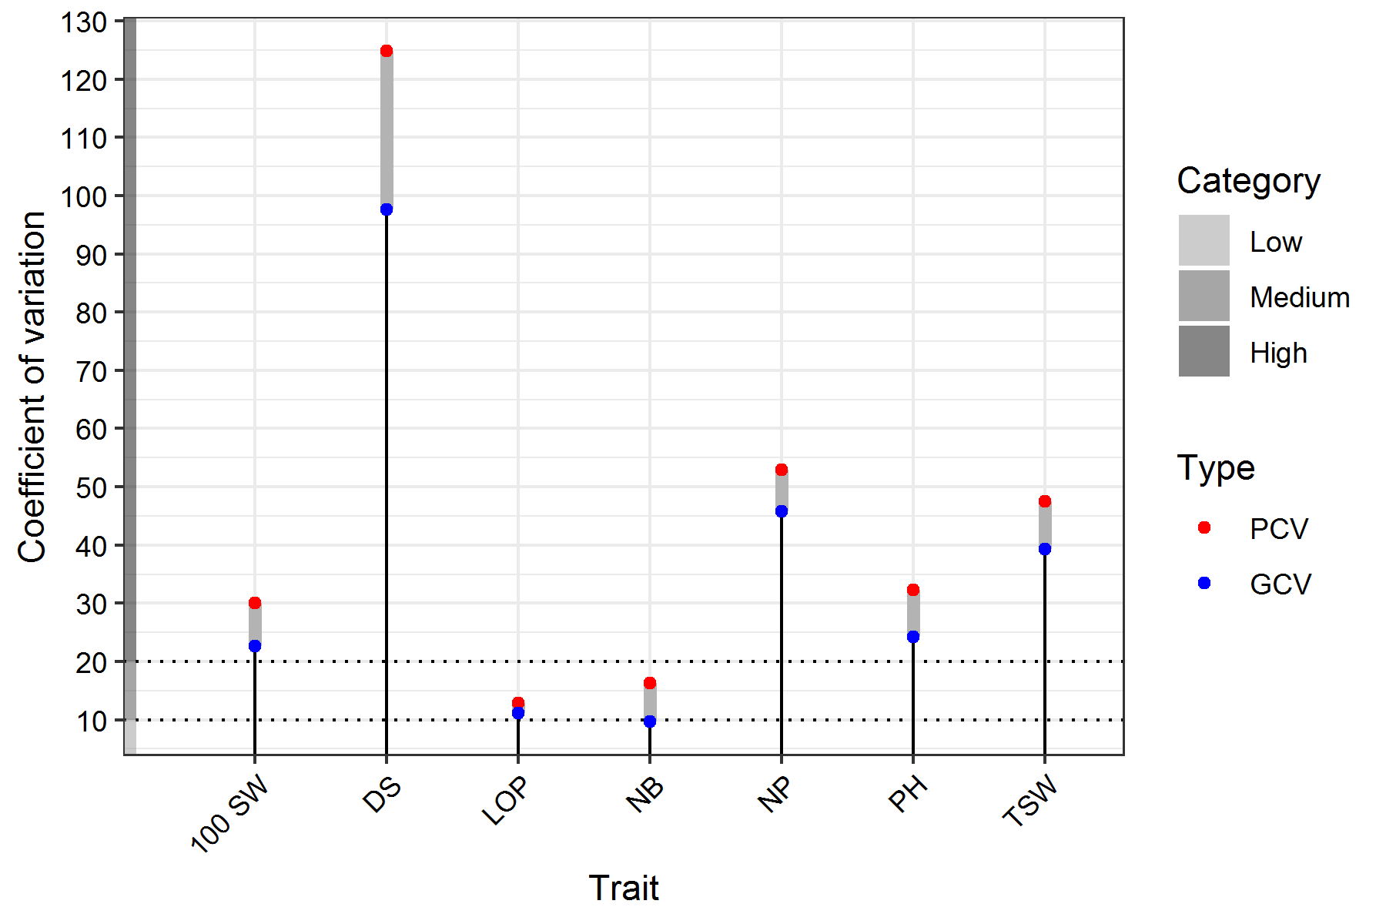

## Broad Sense Heritability

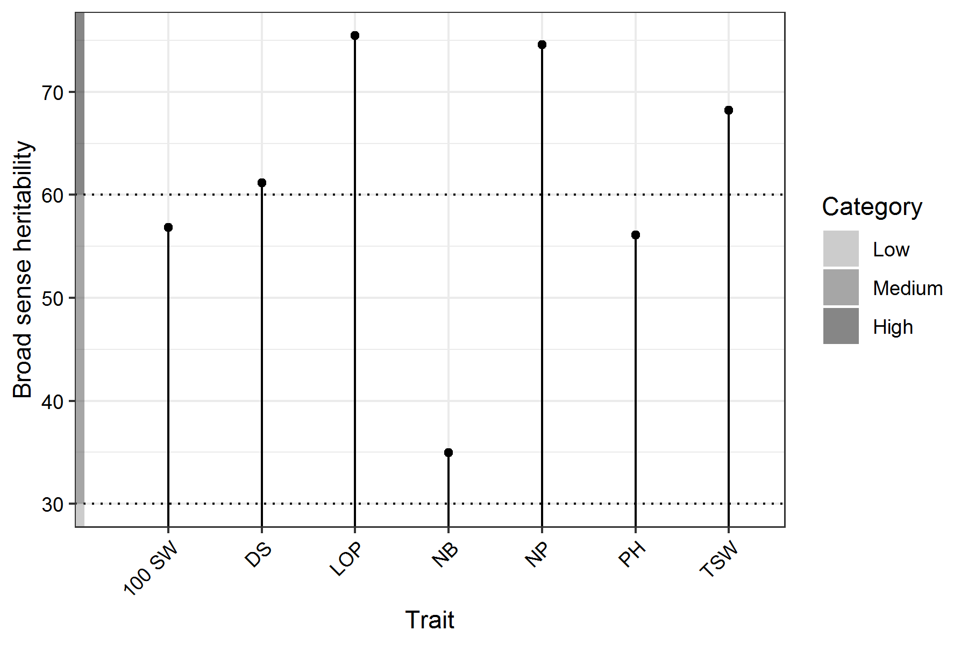

## Genetic Advance Over Mean

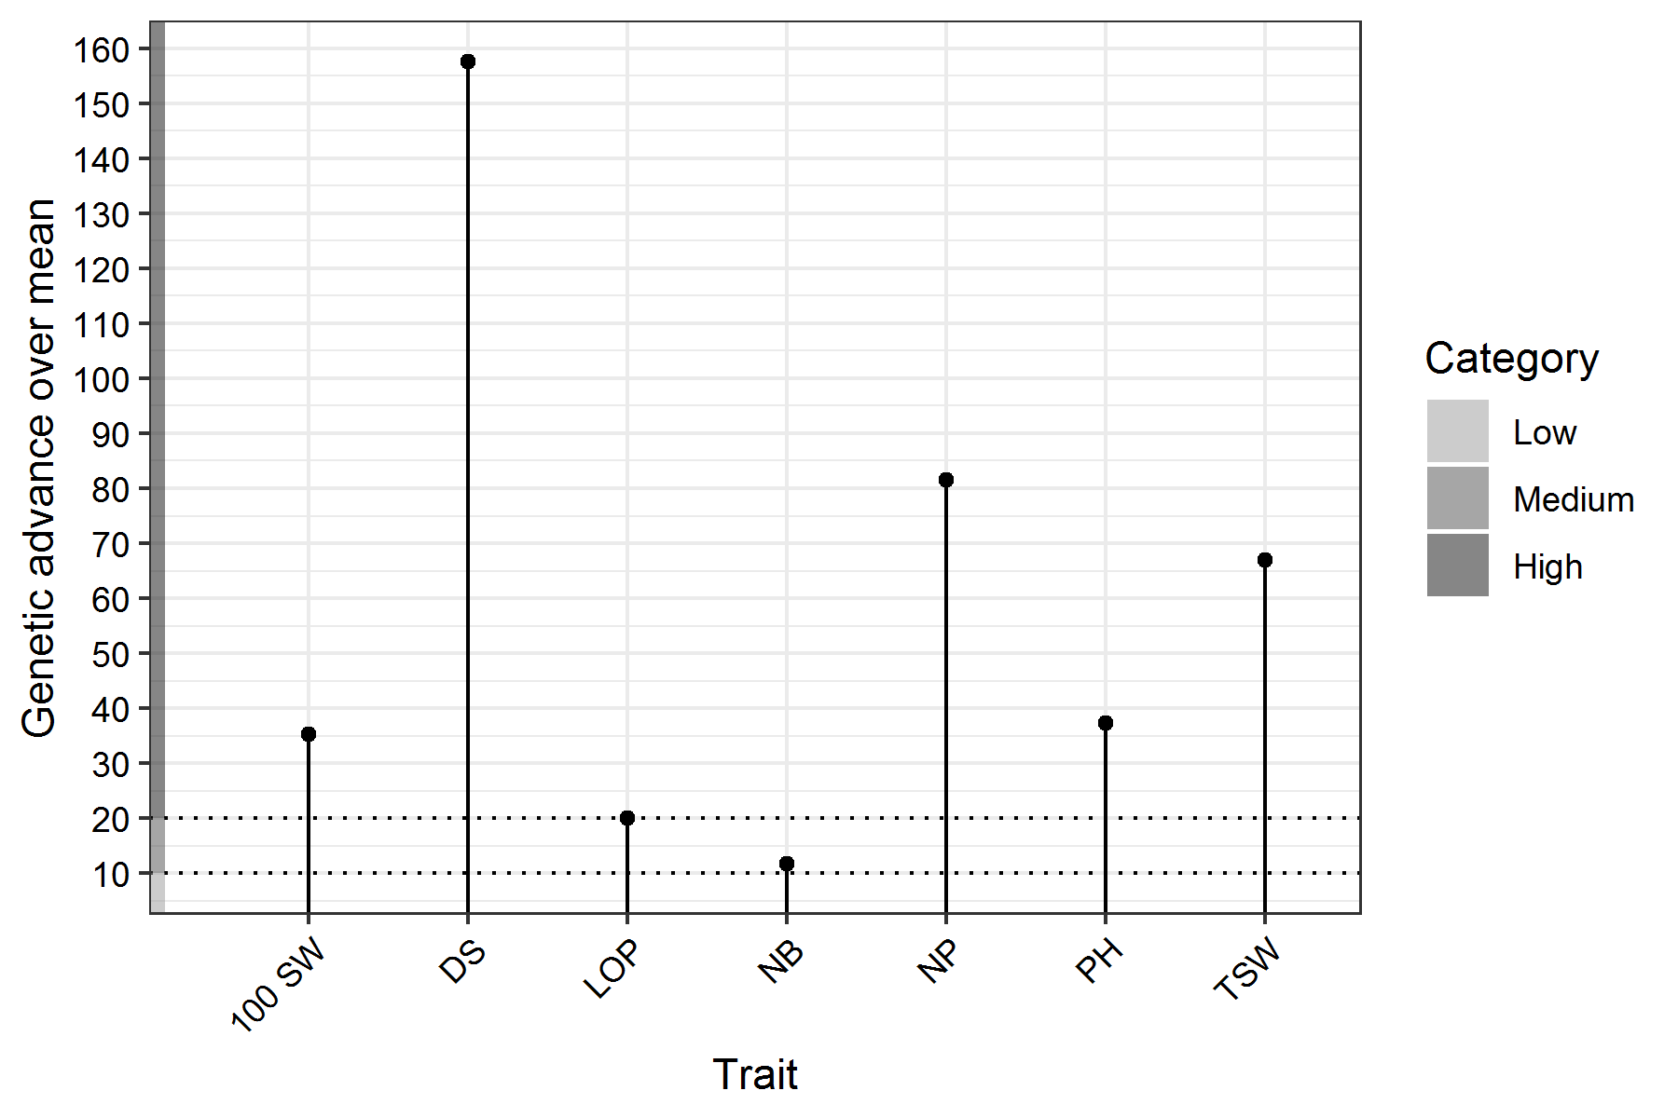

# Adjusted Means

| **Treatment** | **X100.SW** | **DS** | **LOP** | **NB** | **NP** | **PH** | **TSW** |
| --- | --- | --- | --- | --- | --- | --- | --- |
| 198355(45) | 8.21 | 0 | 17.69 | 2.13 | 4.45 | 27.8 | 57.82 |
| 201095-(32) | 11.17 | 7.86 | 11.85 | 2.3 | 4.05 | 37.52 | 171.3 |
| 202521(93) | 11.77 | 10.11 | 14.45 | 2.5 | 1.85 | 56.72 | 149.2 |
| 202804(83) | 8.81 | 2.72 | 12 | 2.63 | 6.32 | 36.46 | 76.83 |
| 2574422(7) | 11.72 | 0.02 | 8.97 | 2.79 | 12.18 | 40.82 | 113.92 |
| 97767 (10) | 10.62 | 13.66 | 15.33 | 2.59 | 6.58 | 36.06 | 98.72 |
| C-24-1 | 11.21 | 0 | 15.65 | 3.73 | 10.25 | 50.4 | 91.82 |
| C-325 | 11.27 | 8.72 | 14.17 | 2.9 | 8.05 | 55.82 | 119.5 |
| C-33 | 12.49 | 2.18 | 11.59 | 2.41 | 9.15 | 37.96 | 87.71 |
| CB-10 | 8.61 | 0 | 11.25 | 2.73 | 6.45 | 47.28 | 81.52 |
| CP-98 | 7.71 | 23.46 | 11.61 | 2.73 | 6.65 | 36.2 | 91.52 |
| EC-075180 | 10.77 | 21.42 | 13.57 | 1.9 | 3.85 | 26.42 | 61.6 |
| EC-102065 | 24.87 | 7.28 | 12.77 | 2.1 | 4.05 | 30.12 | 68.9 |
| EC-170584 | 11.66 | 0 | 12.05 | 2.56 | 6.11 | 33.49 | 63.02 |
| EC-170584 (B-9) | 9.61 | 5.65 | 13.65 | 2.53 | 5.45 | 34.3 | 127.52 |
| EC-1705840-9 | 10.51 | 6.98 | 11.65 | 2.59 | 5.32 | 59.78 | 61.15 |
| EC-170604 | 8.86 | 12.12 | 12.49 | 2.39 | 4.32 | 30.44 | 57.55 |
| EC-394708 | 10.51 | 3.46 | 12.65 | 2.06 | 6.78 | 40.08 | 57.24 |
| EC-394779 | 8.82 | 0.02 | 13.89 | 2.19 | 4.58 | 22.02 | 61.82 |
| EC-402104 | 11.01 | 0 | 15.05 | 3.13 | 8.25 | 34.46 | 84.52 |
| EC-402159 | 13.27 | 0 | 15.09 | 2.3 | 6.65 | 41.62 | 89.4 |
| EC-458402 | 8.38 | 5.96 | 13.04 | 2.63 | 4.58 | 33.75 | 65.17 |
| EC-458411 | 9.67 | 0 | 12.41 | 1.7 | 3.45 | 43.72 | 50.9 |
| EC-458418 | 13.29 | 1.84 | 12.51 | 1.84 | 3.72 | 25.53 | 59.46 |
| EC-458440 | 10.12 | 0.02 | 12.01 | 1.99 | 4.38 | 28.3 | 43.92 |
| EC-458442 | 11.27 | 13.23 | 12.65 | 2.1 | 3.05 | 50.22 | 123.4 |
| EC-458469 | 9.82 | 3.72 | 12.05 | 1.99 | 4.18 | 25.8 | 63.42 |
| EC-458473 | 8.62 | 0.02 | 12.09 | 2.39 | 5.18 | 37.34 | 103.62 |
| EC-458480 | 8.85 | 0.94 | 13.65 | 2.3 | 4.47 | 35.76 | 88.32 |
| EC-458483 | 8.91 | 7.7 | 14.05 | 2.59 | 7.92 | 39.18 | 119.15 |
| EC-458489 | 9.51 | 10.55 | 12.25 | 2.39 | 2.72 | 29.12 | 65.45 |
| EC-458505 | 10.01 | 0 | 12.33 | 2.53 | 7.85 | 57.96 | 80.02 |
| EC-472250 | 10.42 | 0.02 | 9.93 | 2.19 | 5.58 | 26.02 | 85.62 |
| EC-472252 | 9.51 | 24.93 | 12.61 | 3.33 | 6.45 | 40.12 | 79.42 |
| EC-472257 | 9.51 | 12.96 | 13.21 | 2.39 | 6.52 | 47.4 | 49.55 |
| EC-472267 | 11.37 | 24.08 | 11.93 | 2.1 | 6.45 | 30.02 | 144.5 |
| EC-492292 | 12.77 | 13.74 | 12.09 | 2.1 | 5.45 | 52.02 | 203.3 |
| GC-3 | 7.61 | 2.44 | 10.77 | 2.59 | 9.72 | 46.86 | 138.25 |
| GC-810 | 7.91 | 8.89 | 13.05 | 2.39 | 3.52 | 48.94 | 65.55 |
| GENDTYPE-36 | 4.81 | 12.19 | 13.61 | 2.39 | 5.12 | 30.14 | 68.25 |
| GP-132 | 13.57 | 9.73 | 12.69 | 2.3 | 6.45 | 34.72 | 59.38 |
| GP-86 | 4.61 | 9.34 | 13.93 | 2.79 | 2.92 | 38.06 | 52.05 |
| GWHOPE | 9.11 | 2.44 | 9.77 | 2.39 | 2.92 | 40.02 | 59.95 |
| IC-1061 | 10.72 | 8.71 | 12.33 | 2.39 | 5.38 | 49.76 | 96.22 |
| IC-1070 | 11.57 | 20.68 | 13.29 | 2.5 | 4.85 | 34.92 | 167.6 |
| IC-1071 | 10.11 | 0 | 11.57 | 2.73 | 6.25 | 30.9 | 84.42 |
| IC-202290 | 2.31 | 2.44 | 13.33 | 2.39 | 2.52 | 25.3 | 75.55 |
| IC-202711(58) | 7.67 | 0 | 10.65 | 1.9 | 6.85 | 19.32 | 52.56 |
| IC-202777 | 11.91 | 22.18 | 14.21 | 2.69 | 5.55 | 32.55 | 94.99 |
| IC-202781 | 9.87 | 3.7 | 12.18 | 2.4 | 5.45 | 34.67 | 92.7 |
| IC-202792-(72) | 9.41 | 2.44 | 14.29 | 3.79 | 5.32 | 61.86 | 47.25 |
| IC-206240 | 6.51 | 2.44 | 13.89 | 2.59 | 5.72 | 35.56 | 87.15 |
| IC-219489 | 7.41 | 13.55 | 13.73 | 2.39 | 4.52 | 53.28 | 82.09 |
| IC-237422 | 13.87 | 30.94 | 12.05 | 2.1 | 2.05 | 31.02 | 131.8 |
| IC-249141 | 9.67 | 21.42 | 11.33 | 1.9 | 6.45 | 32.72 | 112.7 |
| IC-249588 | 9.52 | 0.02 | 18.25 | 2.19 | 3.38 | 29.26 | 93.02 |
| IC-249593 | 11.92 | 0.02 | 14.45 | 3.59 | 7.18 | 31.44 | 83.92 |
| IC-25105 | 9.92 | 0.02 | 15.69 | 2.59 | 5.18 | 34.7 | 166.02 |
| IC-2591054 | 8.86 | 5.11 | 12.43 | 2.56 | 5.58 | 39.41 | 90.04 |
| IC-330996 | 9.11 | 0 | 12.73 | 2.53 | 4.45 | 27.4 | 86.52 |
| IC-402090 | 15.01 | 2.32 | 12.49 | 2.53 | 5.45 | 34.72 | 94.52 |
| IC-402098 | 23.82 | 0.02 | 14.09 | 2.19 | 5.78 | 32.48 | 99.12 |
| IC-402101 | 8.26 | 2.44 | 12.45 | 2.49 | 5.12 | 39.21 | 88 |
| IC-402106 | 5.41 | 2.44 | 11.89 | 2.39 | 4.32 | 38.16 | 47.25 |
| IC-402114 | 11.62 | 0.02 | 19.21 | 2.19 | 8.18 | 62.14 | 66.92 |
| IC-402135 | 10.82 | 5.57 | 12.09 | 2.59 | 4.98 | 40.34 | 82.12 |
| IC-402154 | 6.72 | 16.69 | 14.81 | 2.79 | 9.98 | 36.76 | 169.72 |
| IC-402159 | 9.21 | 2.44 | 12.37 | 2.19 | 2.52 | 20.06 | 56.85 |
| IC-402164 | 24.07 | 21.14 | 12.17 | 1.7 | 9.45 | 35.92 | 96.2 |
| IC-402166 | 8.96 | 4.31 | 13.03 | 2.26 | 4.38 | 37.73 | 102.04 |
| IC-402172 | 8.71 | 2.64 | 12.11 | 2.53 | 7.65 | 37.76 | 65.67 |
| IC-402175 | 9.49 | 1.4 | 13.29 | 2.21 | 6.85 | 33.56 | 72.36 |
| IC-402180 | 11.39 | 15.46 | 12.37 | 2.24 | 5.39 | 48.8 | 122.33 |
| IC-422174 | 7.72 | 6.08 | 13.09 | 2.39 | 5.38 | 22.06 | 51.42 |
| IC-4506 | 10.06 | 0 | 11.49 | 2.66 | 4.91 | 28.31 | 78.52 |
| IC-458430 | 12.41 | 7.63 | 10.05 | 2.93 | 5.45 | 31.2 | 166.42 |
| IC-462090 | 11.22 | 10.73 | 12.77 | 2.99 | 12.78 | 27.5 | 138.82 |
| IC-58905 | 12.67 | 0.24 | 14.49 | 1.7 | 3.85 | 45.22 | 105.3 |
| IC -402164 | 7.22 | 16.69 | 11.49 | 2.59 | 5.58 | 28.02 | 61.42 |
| IC -402180 | 10.02 | 7.16 | 14.13 | 2.39 | 6.18 | 53.66 | 59.22 |
| IT-97K499-38 | 6.11 | 12.96 | 11.49 | 2.39 | 13.52 | 12.96 | 63.85 |
| KBC--2 | 10.51 | 2.79 | 11.61 | 2.53 | 5.65 | 33.4 | 95.89 |
| KM-5 | 11.37 | 8.72 | 11.21 | 3.3 | 17.25 | 51.82 | 59.2 |
| MBC-25 | 7.87 | 21.14 | 12.93 | 3.3 | 9.25 | 44.52 | 44.5 |
| NBC-16 | 11.21 | 30.7 | 10.81 | 3.73 | 6.85 | 36.1 | 96.42 |
| NBC-18 | 10.47 | 0.17 | 13.17 | 1.9 | 4.45 | 27.92 | 67.1 |
| NBC-24 | 14.71 | 0 | 12.81 | 2.13 | 7.25 | 39.1 | 84.42 |
| NBC-30 | 8.71 | 15.77 | 11.05 | 2.39 | 3.92 | 37.64 | 102.65 |
| NBC-33 | 11.27 | 25.61 | 11.13 | 2.3 | 7.25 | 63.02 | 229.8 |
| NBC-36 | 9.07 | 10.11 | 12.97 | 2.5 | 6.45 | 42.92 | 34.3 |
| NBC-38 | 11.29 | 8.62 | 12.59 | 2.11 | 5.55 | 36.51 | 68.16 |
| NBC-39 | 9.41 | 0 | 12.01 | 2.33 | 6.65 | 44.42 | 118.62 |
| NBC-41 | 11.82 | 0.02 | 11.53 | 2.19 | 7.18 | 27 | 114.72 |
| NBC-43 | 9.27 | 5.01 | 11.91 | 2 | 3.65 | 31.87 | 61.5 |
| NBC-44 | 9.02 | 2.52 | 12.21 | 2.59 | 8.38 | 59 | 63.22 |
| NBC-6 | 16.27 | 0 | 13.49 | 2.1 | 20.85 | 48.52 | 233.7 |
| NBC-7 | 3.91 | 8.5 | 12.09 | 2.59 | 3.12 | 55.66 | 62.35 |
| NBC-8 | 10.32 | 6.47 | 14.45 | 2.59 | 8.78 | 25.62 | 45.22 |
| V-240 | 7.31 | 17.08 | 12.49 | 2.13 | 9.85 | 41.8 | 67.82 |
| V-578 | 3.91 | 5.14 | 13.17 | 2.79 | 4.72 | 38.26 | 53.25 |
| V-578( C ) | 7.21 | 13.87 | 14.61 | 2.79 | 7.12 | 36.16 | 67.65 |
| V-585 | 10.78 | 6.94 | 13.33 | 2.45 | 7.85 | 43.71 | 88.3 |

# Warnings

## Model

PH

Test treatments are replicated

NB

Test treatments are replicated

NP

Test treatments are replicated

LOP

Test treatments are replicated

100 SW

Test treatments are replicated

TSW

Test treatments are replicated

DS

Test treatments are replicated

DS

Negative adjusted means for the following treatment(s) 198355(45), C-24-1, CB-10, EC-170584, EC-170584, EC-402104, EC-402159, EC-458411, EC-458505, IC-1071, IC-202711(58), IC-330996, IC-4506, IC-4506, NBC-24, NBC-39, NBC-6 They were truncated to zero

## Frequency Distribution

PH

Removed 2 rows containing missing values (geom_bar).

NB

Removed 2 rows containing missing values (geom_bar).

NP

Removed 2 rows containing missing values (geom_bar).

LOP

Removed 2 rows containing missing values (geom_bar).

100 SW

Removed 2 rows containing missing values (geom_bar).

TSW

Removed 2 rows containing missing values (geom_bar).

DS

Removed 2 rows containing missing values (geom_bar).

## Genetic Variablity Analysis

NB

P-value for "Treatment: Test" is > 0.05. Genetic variability analysis may not be appropriate for this trait.

################## The End ##################